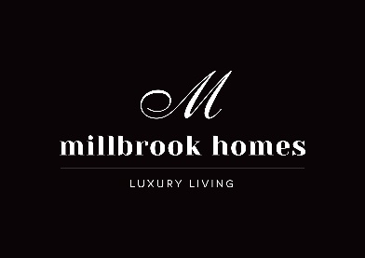

NEWS RELEASE
7 September, 2017

Millbrook Homes based in Bella Vista, has received two respected accolades at the 2017 Master Builders Association (MBA) NSW awards held at The Star in Pyrmont.

Category award wins included Design and Construct - $2.5 to $3 million and Home Unit Renovation - $600,001 to $1 million.

Richard Whitehead, Director of Millbrook Homes said, “It is a privilege to be recognised by the industry at the MBA awards. In recent years, the company has won many prestigious industry awards. These accolades pay homage to the hard work of our dedicated team who consistently deliver high-quality custom designed homes.

“Setting industry benchmarks is what we are striving to do in the luxury home space. We look forward to continuing to influence the market with our high-end boutique homes,” added Daniel Whitehead, Director of Millbrook Homes.

The MBA awards recognise exemplary home innovation, materials, construction, and design. Judge Stephen Rayner comments on the Design and Construct winning home, “From the entry, the living area is a few steps down and opens to a large, lofty area with high ceilings and full-height windows which gives a feeling of space. Large picture windows allow for great views of the golf course. There are many high-end finishes throughout the house which have been well executed.”

Judge Ross Finnie comments on the Home Unit Renovation, “Starting with a bare shell on a top floor unit block caused several problems. Placing all the services into the available space was no mean feat. The finishes throughout are of a very high standard.”

Positioned in the heart of the Hunter Valley in Rothbury, the Design and Construct winning custom built home capitalises on the site’s position, next to a lake and golf course and has been designed to take advantage of the spectacular un-interrupted views and favourable solar orientation. Key features include a mix of contemporary and traditional finishes to the elongated façade, impressive glass pavilion with 5 metre ceilings (floor to ceiling glass) and the master bedroom has been designed as a private wing.

The North Sydney home unit renovation presented a rare opportunity to deliver a luxurious penthouse in the heart of North Sydney. Taking in the panoramic views of Sydney Harbour, the apartment exudes elegance and sophistication, supported by exceptional craftsmanship. Encapsulating a ‘New York’ style apartment interior, the penthouse perfectly blends timeless traditional aesthetics with sleek and modern finishes.

For further information visit www.millbrook.sydney

Media contact: Natasha McGuire, Red Leopard PR, Phone: 02 9328 4248 or

